Module 02 Course Project - Design Your First Home Page

Aline jean Louis Maxi

CIS3801C Section 01 Fundamentals of Mobile Web Application Development

Professor: Kris Jamsa

October 14, 2018

The website is going to be about a business that I intend to do after my graduation as a computer scientist. I will provide users with online services such as: IT management, web design, web development, custom site design, site repair and maintenance, cloud services and etc. The name will be JLMax web-tech services (I already had the domain name: jlmaxwts.com). On the website users will be able to make a payment, request a ticket, chat with personal support, etc.

1-

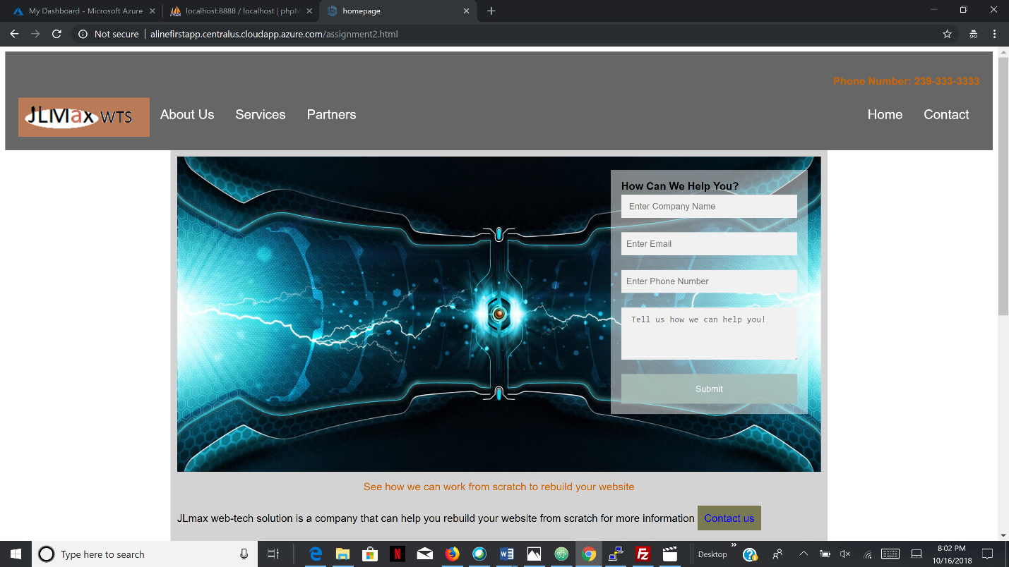

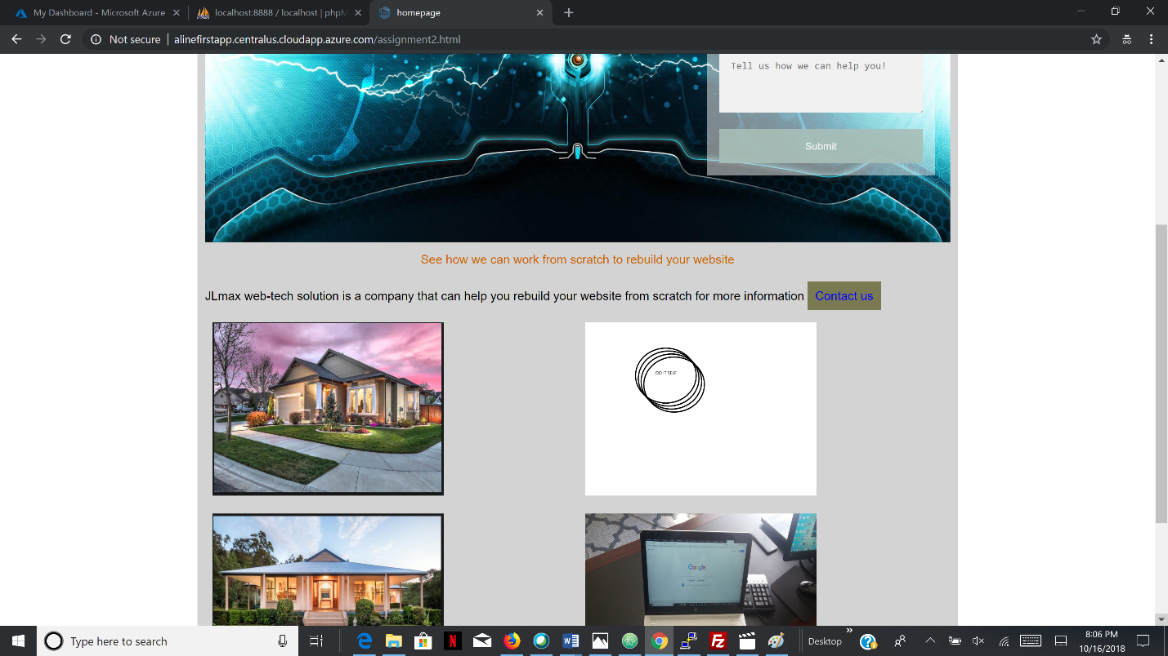

3- 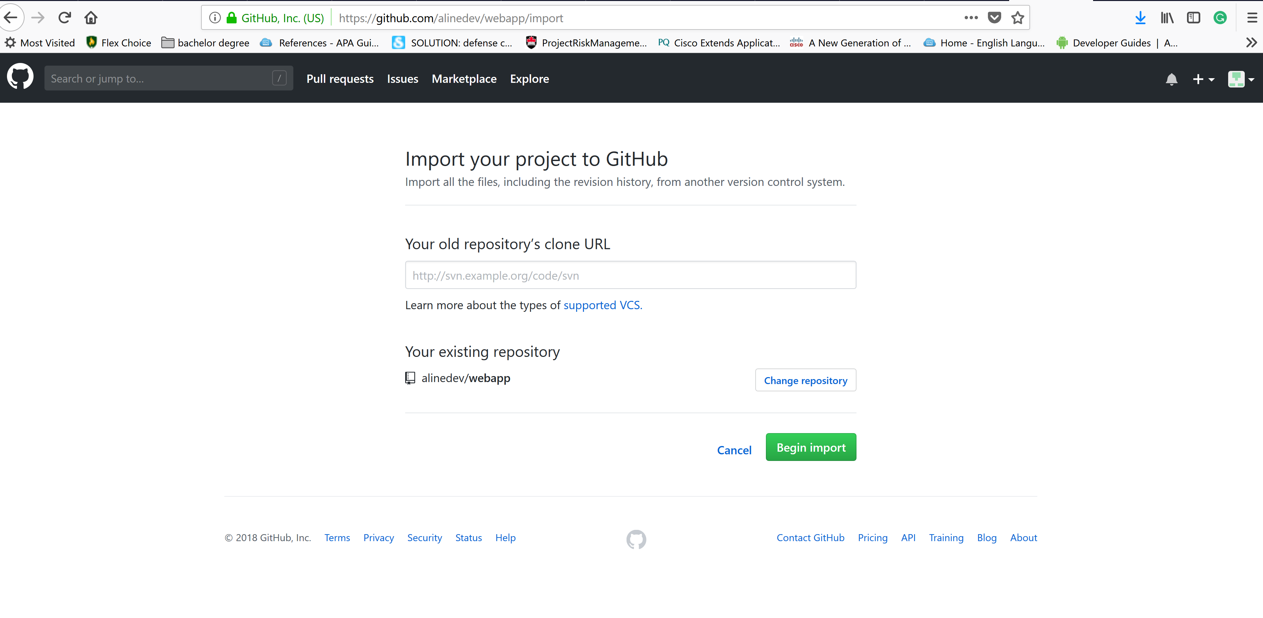

4-

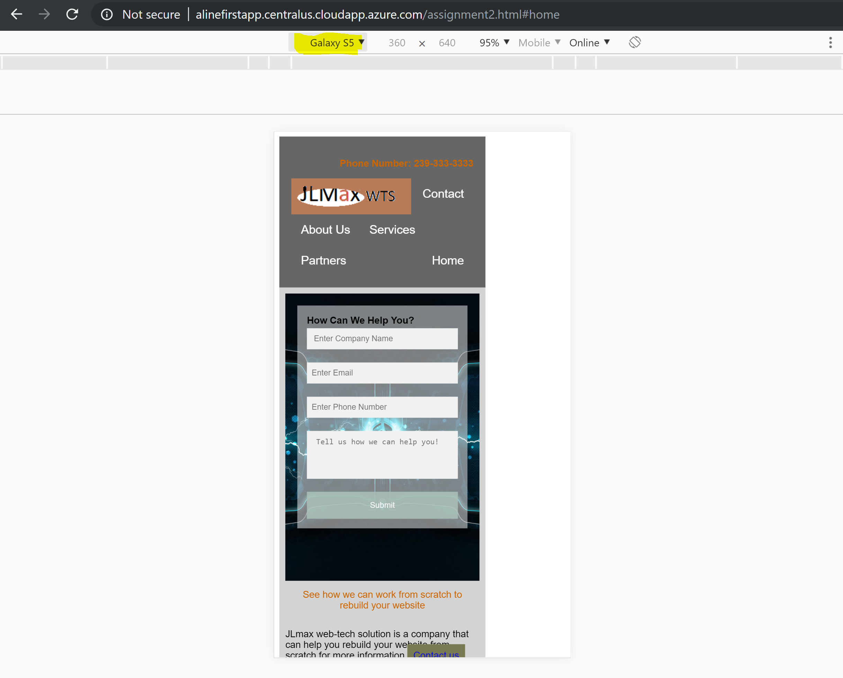

5-

